- B - Four-month war – One arctic
winter 1939/40

Autumn 1939 scenario

On the 1st of September 1939, Germany attacked Poland by land, air and water. Soon, the Nazis deployed 5,000 planes in Poland (New York Times, 25th September 1939). On the 25th of September 1939, 240 German planes bombed Warsaw, dropping 560 tons of bombs, including the first 1,000 kg bomb. 30 transport aircrafts dropped 70 tons of firebombs. Meanwhile, 1,000 batteries shelled the city day and night. Warsaw burnt for many days. Poland surrendered before the end of the month. Total casualties were estimated at 1 million, including 200,000 dead men and 700,000 war prisoners.
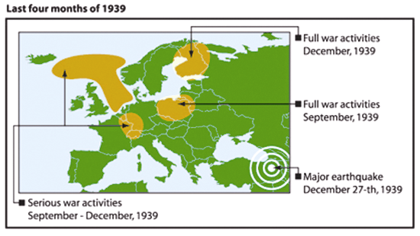
On the 3rd of September, Great Britain and France declared war to Germany. A several hundred kilometre long military defence zone between France and Germany (viz. the Maginot Line and the Westwall) became operative immediately. Two million soldiers faced each other in September 1939. Since October, the number increased to over three million. Attacks and encounters occurred on a frequent basis.

During one of the first attacks, 700 French tanks and planes moved seven miles over the Saarland border, while 300 air planes attacked German positions in the Aachen industrial region and munitions area, some 125 miles further north (NYT, the 7th of September 1939). Similar encounters, of smaller or larger proportions, occurred frequently. But the biggest clash was postponed due to extremely wet conditions, although Hitler had planned to invade France in late autumn.

On the 30th of November 1939, Russian troops invaded Finland with an army of 500,000 men (ca. 30 divisions), 2,000 tanks and 1,000 airplanes, while Finnish strength was much weaker. Fighting took place along a 1,000-kilometre front line, from the Barents Sea to the Gulf of Finland, with few access roads and very low temperatures (-46ºC around Christmas 1939), in the permanent darkness of the northern Polar Circle and with only a few hours of daylight in southern Finland. On the night of 26 to 27 December, Anatolia was hit by a major earthquake which caused the death of 30,000 persons and generated a tsunami in the Eastern Black Sea.

In August 1939, many naval vessels had already been sent to distant positions. When war commenced, warring nations had an armada of 1,000 naval vessels in service. The Baltic and North Sea and Eastern North Atlantic were the preliminary areas of activity. From hour zero, many hundreds of naval vessels were permanently engaged in patrolling, escorting, mine laying, mine sweeping, depth charging submarines, shelling coastal batteries, enemy vessels or enemy air planes.

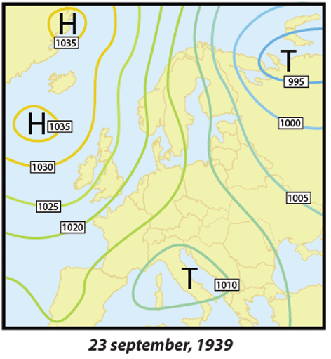
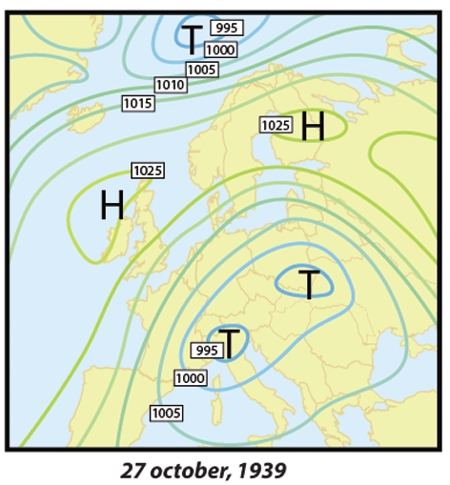
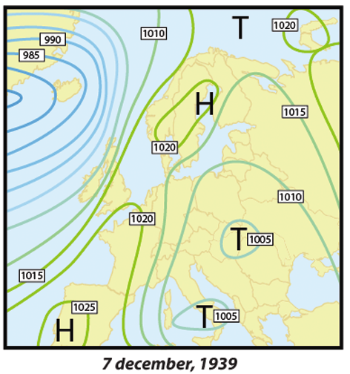
Three weather charts from autumn 1939 demonstrate general air pressure conditions, while the chart of December 7, 1939 shows how toe high pressure block the flow of Atlantic air via Central Europe, which was already observed by the
Neue Zürcher Zeitung, as explained on page 99 (below)
The importance of autumn 1939 for climate research

The autumn of 1939 has a unique importance for the climate research. Even though naval activities were modest compared to what the world saw a few months later and which lasted the next five years, on the 1st of September 1939 climate statistics were free from any “external” influence. Northern European waters had never experienced such a devastating force powered by newly developed military means used firstly in WWII. WWI circumstances differed from those of WWII because during the former naval warfare the destruction progressed rather slowly before becoming serious, in late 1916, with the deployment of new weapons such as U-boats, sea mines, depth charges, etc.

The winter 1938/39 has been the warmest in the past few hundred years. Since the end of the WWI, Europe has been warming year after year. In the 1930s, no abnormal phenomenon has been recorded either in Europe or in a wider region that could have had an impact on the ‘natural course’ of the climate. In fact, the months between January and August 1939 had been slightly wetter than the average but, otherwise, thoroughly normal. Things changed only when WWII started. The impact of naval warfare on natural environment occurred very suddenly. Ocean and atmospheric matters run according to physical laws, for which the principles of conservation apply, except when something of huge proportions change the situation suddenly; an excellent example was the autumn of 1939.

Thanks to accurate climate data recorded in the autumn of 1939, conditions and circumstances that produced the arctic winter all over the Northern Hemisphere, in January 1940, and which maintained in Northern Europe until March 1940 will be discussed in details. To provide a complete picture, the war from China (1936) and an El Niño event 1938/39 which broke out in July/August 1939 will also be included in our presentation.

Methodology of presentation

While investigating what happened to European weather during winter 1939/40, one should logically start with naval activities in the concerned area as they were preconditions for the climate change. Instead, the result, viz. extraordinary winter conditions in January and February 1940, is presented first, whereupon certain relevant aspects are explored subsequently. The agenda will be as it follows:

- Extraordinary winter conditions making it the coldest winter in Northern Germany in more than 110 years and very extreme winter all over Northern Europe.
- Northern European waters and sea under stress. What does it mean to see naval forces in action?
- Warming and cooling process in North and Baltic Sea. Physical conditions and seasonal processes are explained in order to demonstrate that changes were inevitable and that the arrival of arctic cold was not really such a surprise.
- Shut down of west-wind-drift. Europe’s mild climate depends on the flow of moister Atlantic air through its continental realm. War prevented it.
- Forcing rain in Europe – Drying out USA. Seasonal weather stability depends on the amount of water in the atmosphere. War in Europe and China dried the winter sky through excessive rain in autumn.
- Other contributors? War in Finland – Turkish earthquake – El Nino? Other major events in late 1939 are presented for the completion of the picture. None of them did seriously contribute to creating record arctic winter conditions during Europe’s first war winter.
- Which aspects prove any relationship between conducting a war at sea and the resultant change in weather and climate conditions?


